GCP BIGQUERY - ASSIGNMENT

Name: Bhuvanesh L
Roll Number: 23BTRCC009
College Name: Jain University
Batch: 2027
HCL ID: HCLTFP2299117

Creating Database – Eccomerce Database with Table Entries
Query:
CREATE SCHEMA IF NOT EXISTS ecommerce_dataset
OPTIONS(location = 'US');

CREATE OR REPLACE TABLE ecommerce_dataset.orders AS

SELECT 'ORD1001' AS Order_id, 'CUST101' AS Customer_id, 'P101' AS Product_id, DATE '2026-08-05' AS Order_Date, 'Laptop' AS Product, 2 AS Quantity, 55000 AS Unit_Price, 'South' AS Region, 'Delivered' AS Status
UNION ALL
SELECT 'ORD1002', 'CUST102', 'P102', DATE '2026-08-12', 'Smartphone', 1, 25000, 'North', 'Delivered'
UNION ALL
SELECT 'ORD1003', 'CUST103', 'P103', DATE '2026-08-20', 'Headphones', 3, 2000, 'East', 'Completed'
UNION ALL
SELECT 'ORD1004', 'CUST101', 'P104', DATE '2026-09-03', 'Keyboard', 2, 1500, 'South', 'Delivered'
UNION ALL
SELECT 'ORD1005', 'CUST104', 'P101', DATE '2026-09-10', 'Laptop', 1, 55000, 'West', 'Delivered'
UNION ALL
SELECT 'ORD1006', 'CUST105', 'P105', DATE '2026-09-15', 'Monitor', 2, 12000, 'North', 'Completed'
UNION ALL
SELECT 'ORD1007', 'CUST102', 'P103', DATE '2026-09-22', 'Headphones', 2, 2000, 'North', 'Delivered'
UNION ALL
SELECT 'ORD1008', 'CUST106', 'P102', DATE '2026-10-02', 'Smartphone', 2, 25000, 'East', 'Delivered'
UNION ALL
SELECT 'ORD1009', 'CUST103', 'P106', DATE '2026-10-05', 'Mouse', 4, 800, 'South', 'Completed'
UNION ALL
SELECT 'ORD1010', 'CUST101', 'P101', DATE '2026-10-10', 'Laptop', 1, 55000, 'South', 'Delivered'
UNION ALL
SELECT 'ORD1011', 'CUST104', 'P104', DATE '2026-10-12', 'Keyboard', 3, 1500, 'West', 'Pending'
UNION ALL
SELECT 'ORD1012', 'CUST105', 'P105', DATE '2026-10-15', 'Monitor', 1, 12000, 'North', 'Delivered'
UNION ALL
SELECT 'ORD1013', 'CUST102', 'P102', DATE '2026-10-18', 'Smartphone', 1, 25000, 'North', 'Delivered'
UNION ALL
SELECT 'ORD1014', 'CUST107', 'P107', DATE '2026-10-21', 'Printer', 2, 9000, 'East', 'Cancelled'
UNION ALL
SELECT 'ORD1015', 'CUST103', 'P103', DATE '2026-10-25', 'Headphones', 5, 2000, 'South', 'Delivered';

Output:
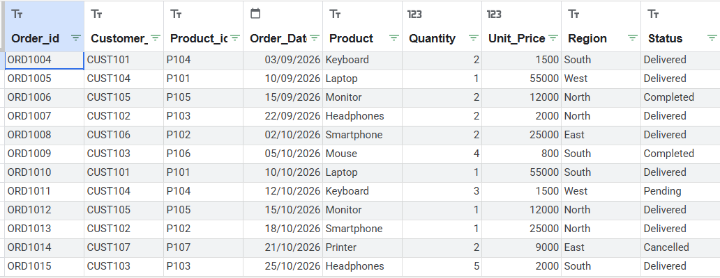

TASK 01: Remove the Duplicate Orders
Query:
SELECT *
FROM ecommerce_dataset.orders
QUALIFY ROW_NUMBER() OVER (
PARTITION BY Order_id
ORDER BY Order_Date
) = 1;

Output:
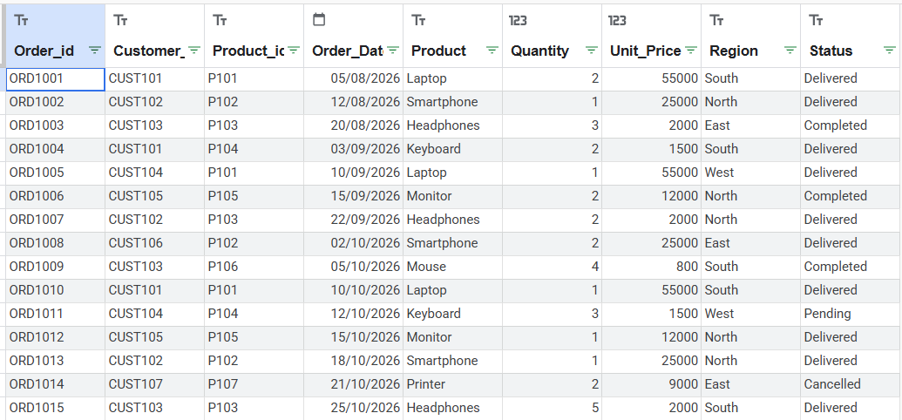

TASK 2: Find the Net Revenue
Query:
SELECT SUM(Quantity * Unit_Price) AS Net_Revenue
FROM ecommerce_dataset.orders
WHERE Status IN ('Delivered', 'Completed');

Output:
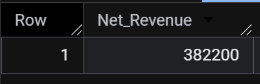

TASK 03: Find the Top 3 Products in each Region
Query:
SELECT Region, Product, Revenue, Product_Rank
FROM (
SELECT Region, Product,
SUM(Quantity * Unit_Price) AS Revenue,
RANK() OVER (
PARTITION BY Region
ORDER BY SUM(Quantity * Unit_Price) DESC
) AS Product_Rank
FROM ecommerce_dataset.orders
WHERE Status IN ('Delivered', 'Completed')
GROUP BY Region, Product
)
WHERE Product_Rank <= 3
ORDER BY Region, Product_Rank;

Output:
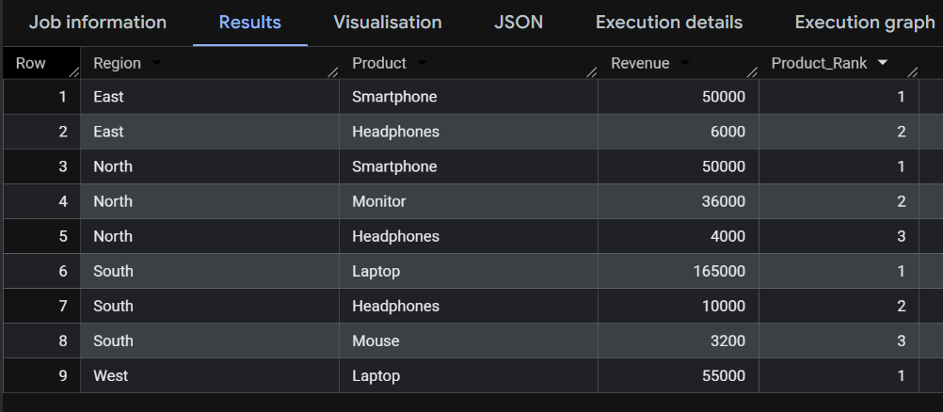

TASK 4: Identify Inactive Customers
Query:
SELECT Customer_id,
MAX(Order_Date) AS Last_Purchase_Date
FROM ecommerce_dataset.orders
WHERE Status IN ('Delivered', 'Completed')
GROUP BY Customer_id
HAVING MAX(Order_Date) < DATE_SUB(
CURRENT_DATE(), INTERVAL 90 DAY
);

Output:
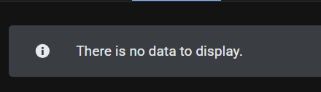

TASK 5: Find the Customers who Purchase Continuously 3 Months
Query:
SELECT Customer_id,
COUNT(DISTINCT FORMAT_DATE('%Y-%m', Order_Date))
AS Months_Purchased
FROM ecommerce_dataset.orders
WHERE Status IN ('Delivered', 'Completed')
AND Order_Date >= DATE '2026-08-01'
AND Order_Date < DATE '2026-11-01'
GROUP BY Customer_id
HAVING COUNT(DISTINCT FORMAT_DATE('%Y-%m', Order_Date)) = 3;

Output:
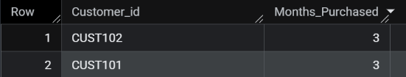

TASK 6: Build a Customer Lifetime Value Report
Query:
SELECT Customer_id,
SUM(Quantity * Unit_Price) AS Lifetime_Revenue,
COUNT(DISTINCT Order_id) AS Total_Orders
FROM ecommerce_dataset.orders
WHERE Status IN ('Delivered', 'Completed')
GROUP BY Customer_id
ORDER BY Lifetime_Revenue DESC;

Output:
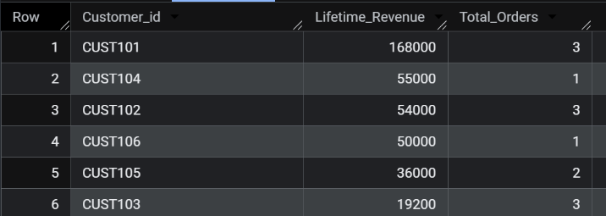

TASK 7: Find the Monthly Sales
Query:
SELECT FORMAT_DATE('%Y-%m', Order_Date) AS Sales_Month,
SUM(Quantity * Unit_Price) AS Monthly_Sales
FROM ecommerce_dataset.orders
WHERE Status IN ('Delivered', 'Completed')
GROUP BY Sales_Month
ORDER BY Sales_Month;

Output:
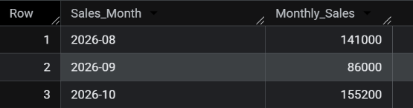

TASK 8: Find the Unit Price Below 10000 in a Particular Month
Query:
SELECT Product, Unit_Price, Order_Date, Status
FROM ecommerce_dataset.orders
WHERE Unit_Price < 10000
AND Order_Date >= DATE '2026-10-01'
AND Order_Date < DATE '2026-11-01'
ORDER BY Unit_Price;

Output:
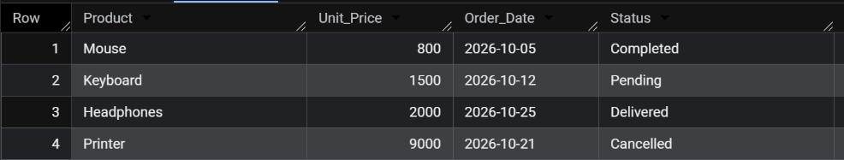

TASK 09: Find the Customer who is Purchased Particular Product Multiple Times in 6 Months
Query:
SELECT Customer_id,
COUNT(DISTINCT Order_id) AS Purchase_Count
FROM ecommerce_dataset.orders
WHERE LOWER(Product) = 'laptop'
AND Status IN ('Delivered', 'Completed')
AND Order_Date >= DATE_SUB(CURRENT_DATE(), INTERVAL 6 MONTH)
GROUP BY Customer_id
HAVING COUNT(DISTINCT Order_id) >= 2;

Output:
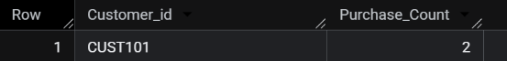

TASK 10: Find the Total Sales Report for each Product in a Particular Month
Query:
SELECT Product,
SUM(Quantity) AS Total_Quantity,
SUM(Quantity * Unit_Price) AS Total_Sales
FROM ecommerce_dataset.orders
WHERE Status IN ('Delivered', 'Completed')
AND Order_Date >= DATE '2026-10-01'
AND Order_Date < DATE '2026-11-01'
GROUP BY Product
ORDER BY Total_Sales DESC;

Output:
